ysyx_22020321-NEMU and NPC

ysyx_22020321-NEMU 3-min

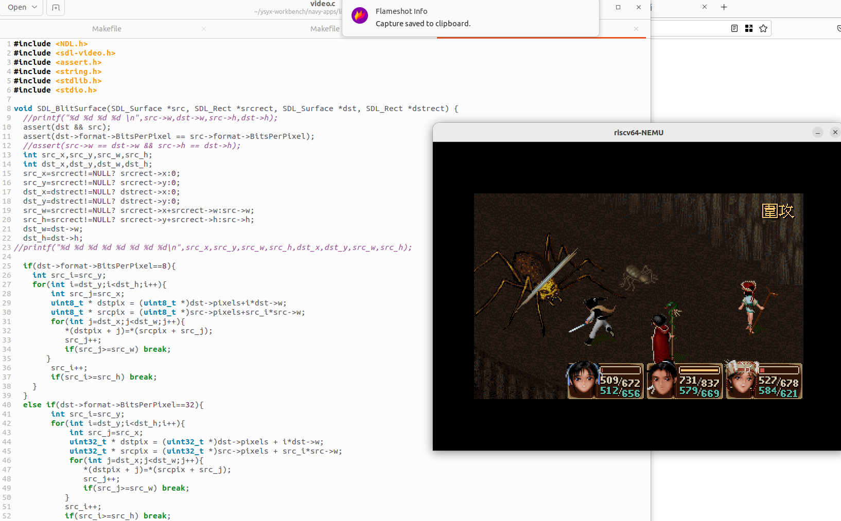

ysyx_22020321-npc 22-min

